How to join USA Archery

- Go to usarchery.org
- Go to Become a Member
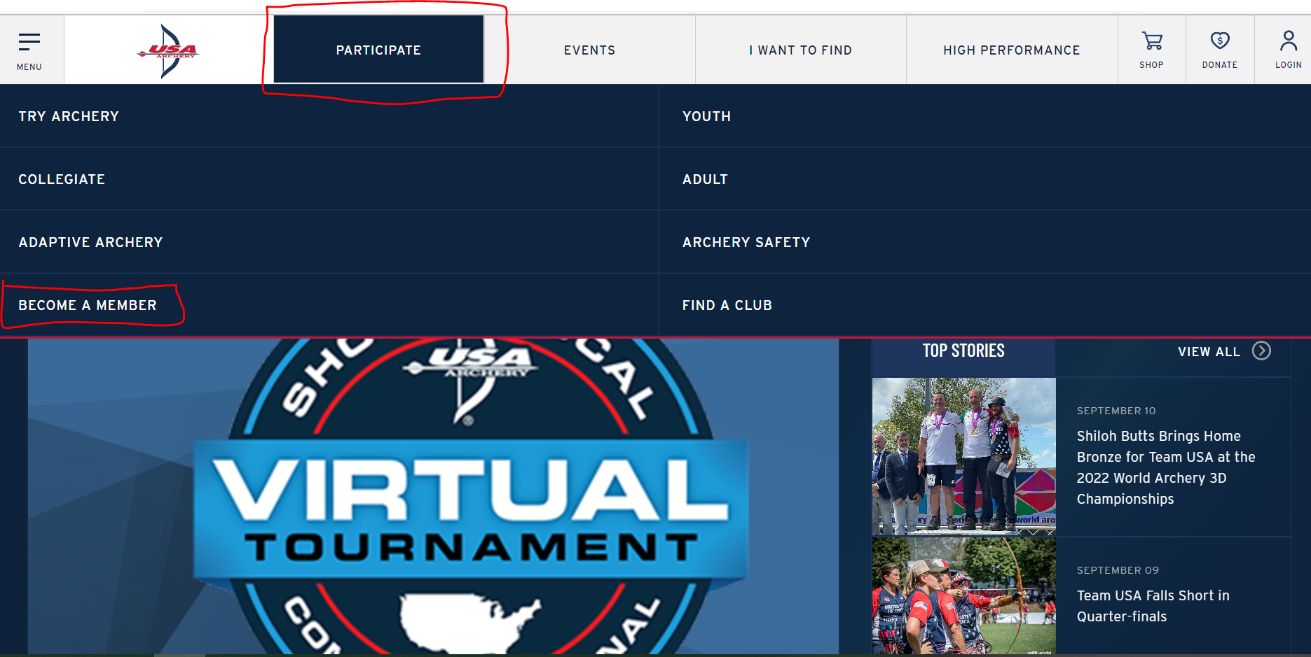
- Select Join Now
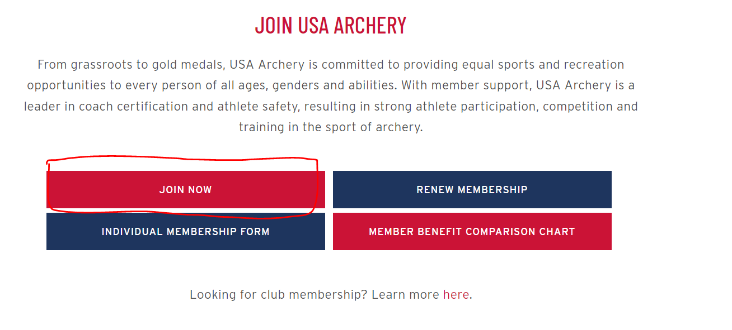
- Enter an email address when prompted.
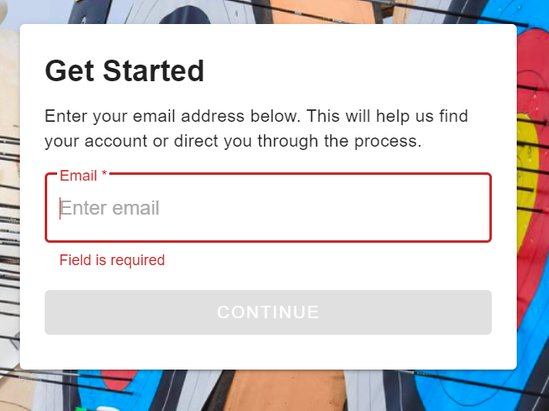
- Populate the information requested and register
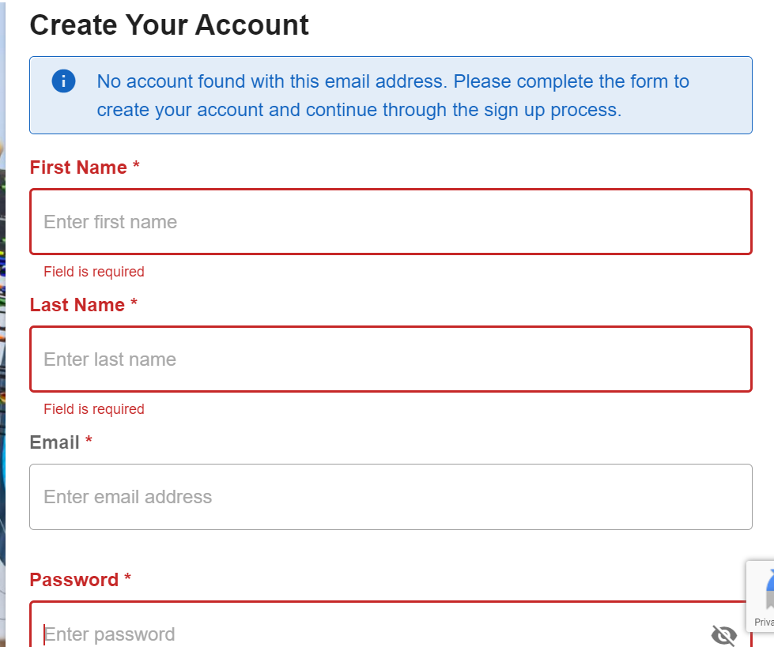

- Populate your communications preferences
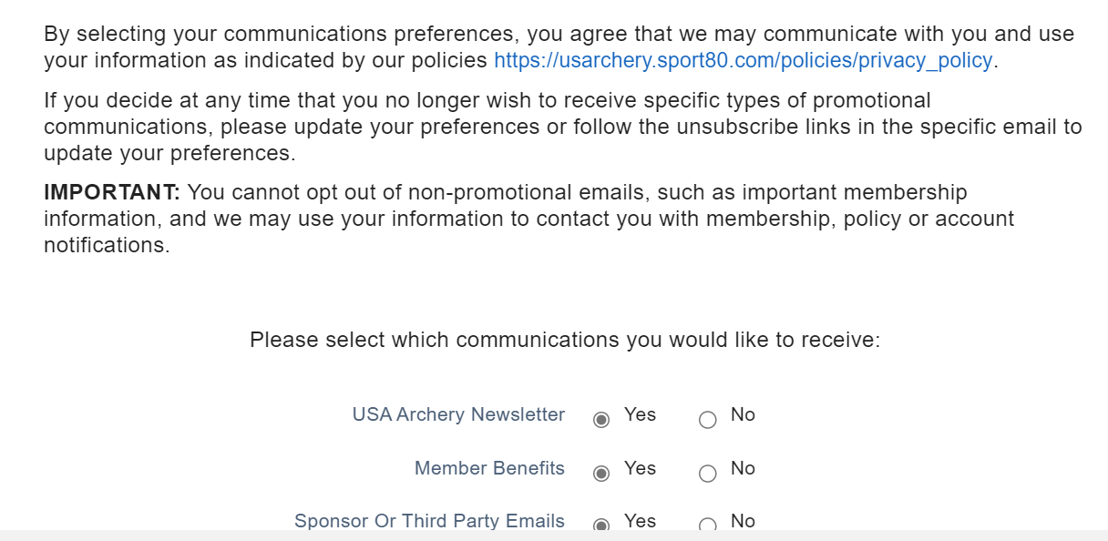
- Select appropriate membership type
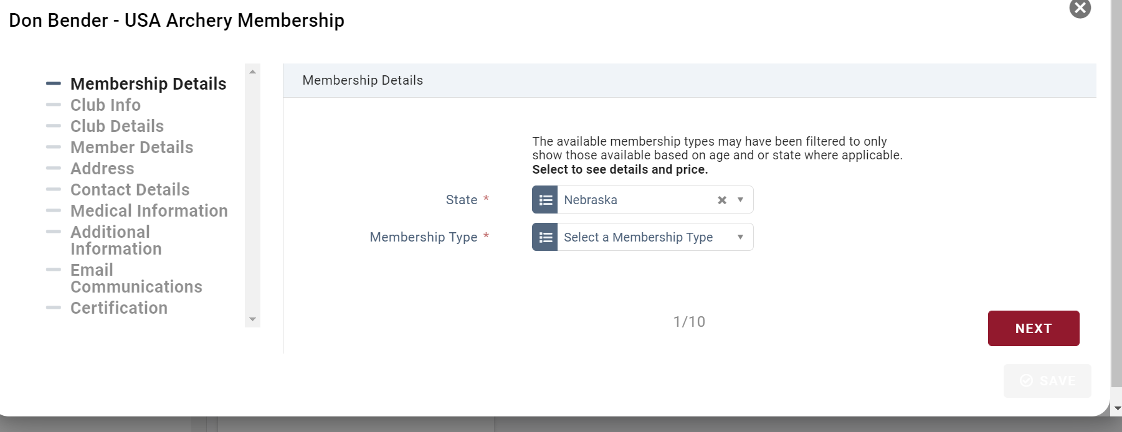
- Select our club:Golden Arrow Archery Club (NE – 4585)
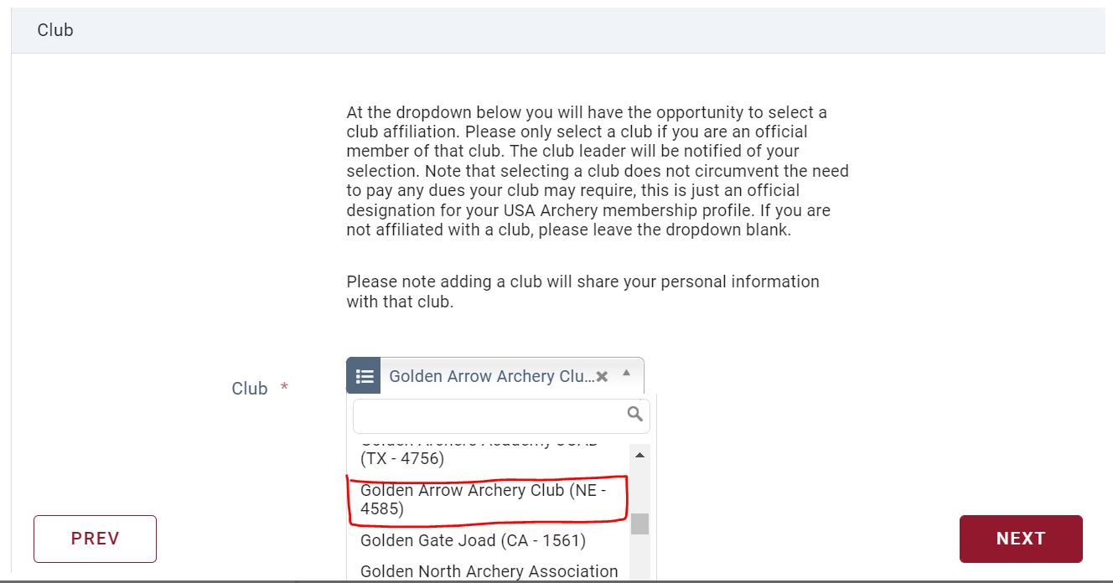
- Select the primary discipline
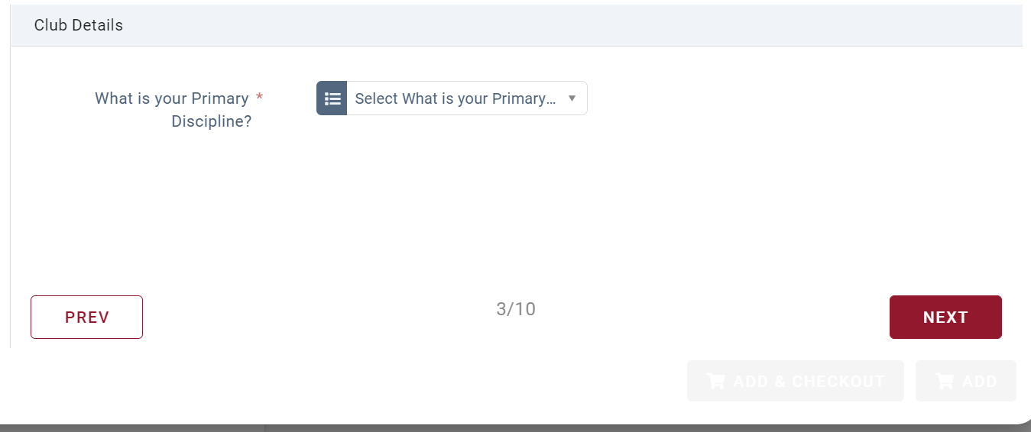
- Confirm Membership details
- Add Address information
- Populate contact details
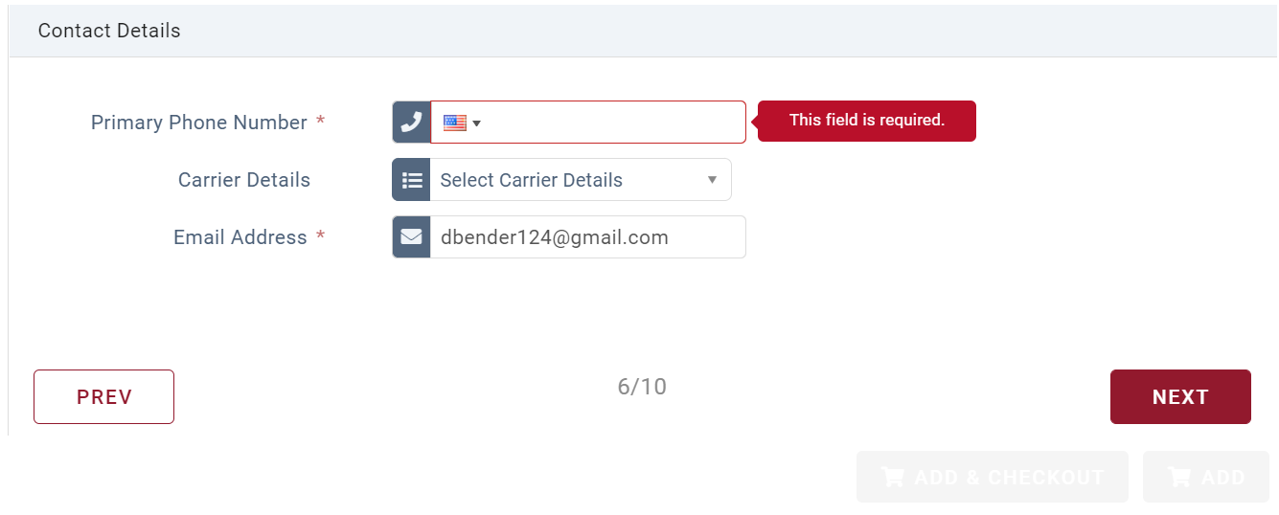
- Enter medical information
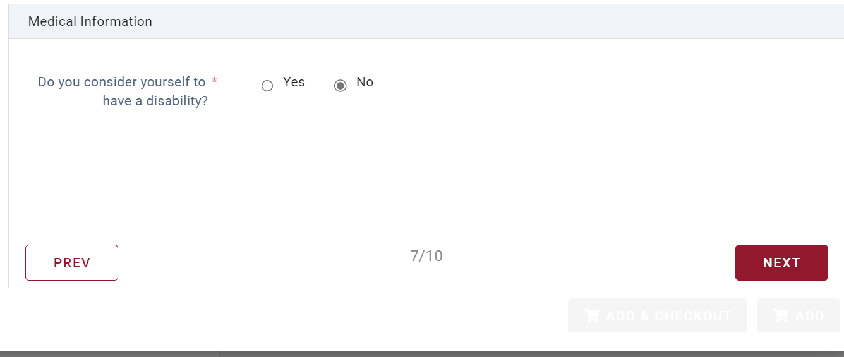
- Populate additional information
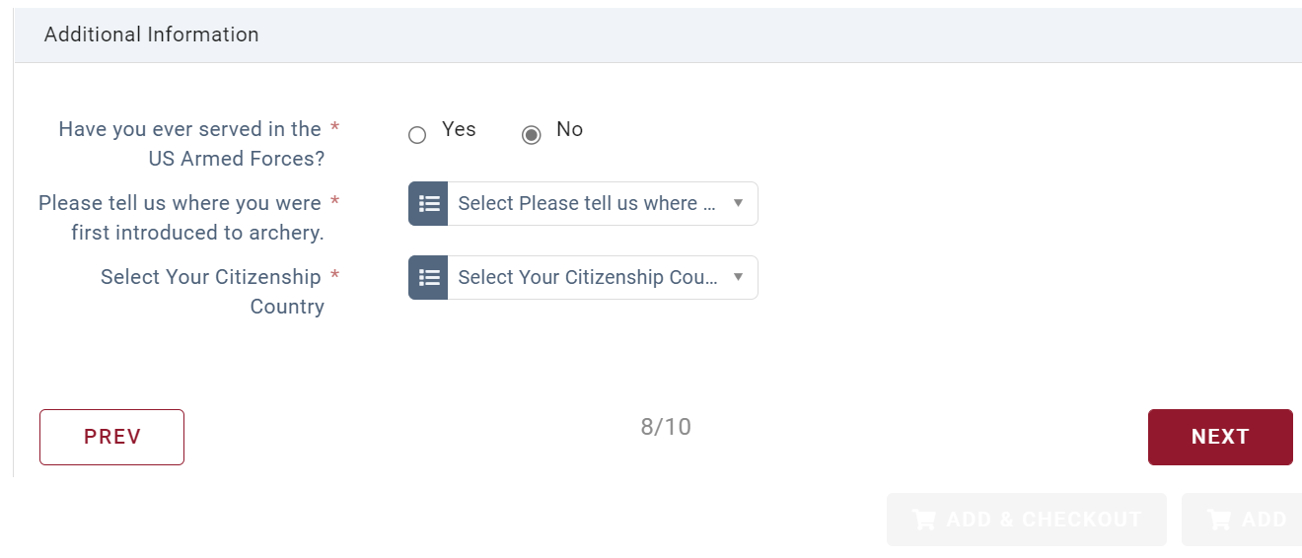
- Add Email communications
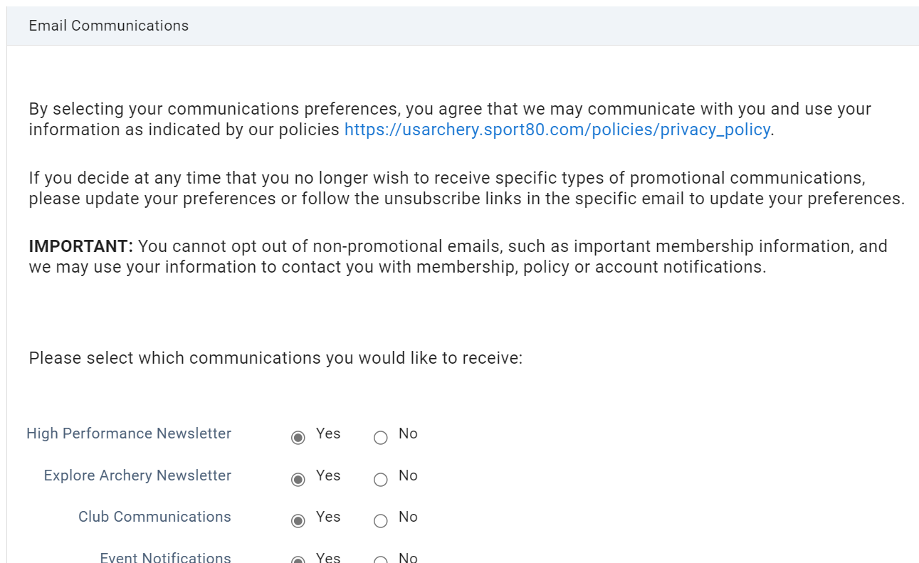
- Certify that you accept the USA Archery terms and conditions
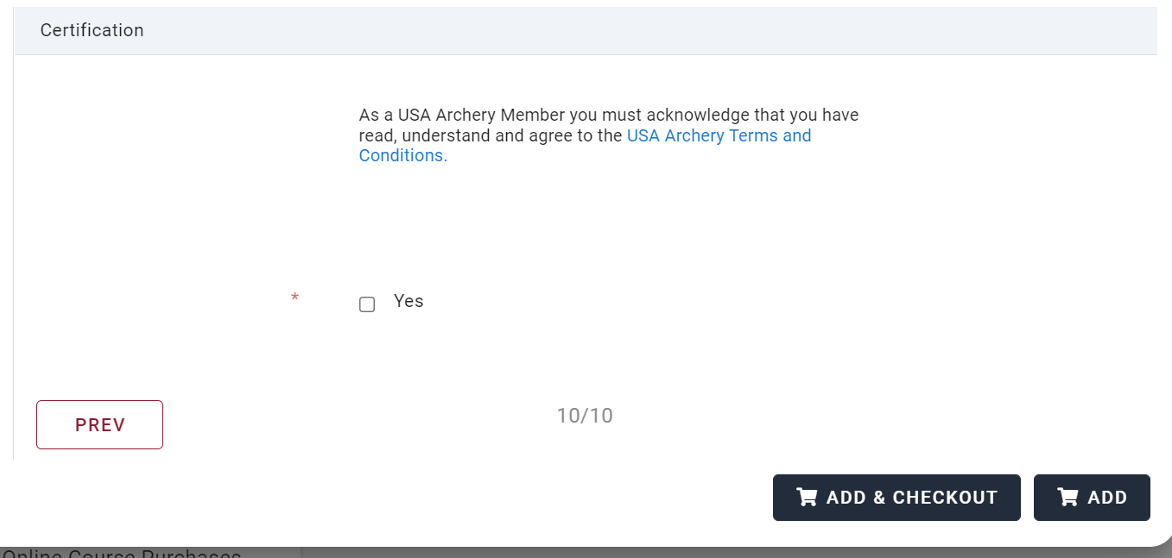
- Select Add & Checkout to pay the membership fee and you will be issued a USA Archery membership number.
- Bring your membership number to JOAD so it can be documented for PIN days.

